World Educational Data

Soumya Vardhana Gari – 11711707
Instructor: Dr. Gahangir Hossain
INFO 5709 Data Visualization And Communication

Project Description:
The chosen dataset global education contains an extensive perspective of educational systems worldwide, offering significant insight regarding the evolving context of educational institutions in numerous countries and territories. Generally, it covers significant factors for things like not attending schools, rate of graduation, skill levels of difficulty, levels of literacy, fertility rates, and about both elementary and secondary school admission individuals, which comprises quite a few issues related to education. This collection of data represents a valuable tool to perceptive intellectuals, motivated instructors, ultimately enlightened officials, presenting the knowledge and skills to individuals to begin a groundbreaking method of monitoring, evolving, and changing educational organizations beyond the world.

Dataset:
The dataset which I have chosen is from Kaggle. The dataset consists the information about educational systems of various countries from different parts of world. This dataset consists of 203 rows which provides data about 202 countries. The link is provided in the below following:
https://www.kaggle.com/datasets/nelgiriyewithana/world-educational-data/data
Attributes:
This dataset consists of about 29 attributes. They are written as follows:
- Countries and Areas: Name of the countries and areas.
- Latitude: Latitude coordinates of the geographical location.
- Longitude: Longitude coordinates of the geographical location.
- OOSR_Pre0Primary_Age_Male: Out-of-school rate for pre-primary age males.
- OOSR_Pre0Primary_Age_Female: Out-of-school rate for pre-primary age females.
- OOSR_Primary_Age_Male: Out-of-school rate for primary age males.
- OOSR_Primary_Age_Female: Out-of-school rate for primary age females.
- OOSR_Lower_Secondary_Age_Male: Out-of-school rate for lower secondary age males.
- OOSR_Lower_Secondary_Age_Female: Out-of-school rate for lower secondary age females.
- OOSR_Upper_Secondary_Age_Male: Out-of-school rate for upper secondary age males.
- OOSR_Upper_Secondary_Age_Female: Out-of-school rate for upper secondary age females.
- Completion_Rate_Primary_Male: Completion rate for primary education among males.
- Completion_Rate_Primary_Female: Completion rate for primary education among females.
- Completion_Rate_Lower_Secondary_Male: Completion rate for lower secondary education among males.
- Completion_Rate_Lower_Secondary_Female: Completion rate for lower secondary education among females.
- Completion_Rate_Upper_Secondary_Male: Completion rate for upper secondary education among males.
- Completion_Rate_Upper_Secondary_Female: Completion rate for upper secondary education among females.
- Grade_2_3_Proficiency_Reading: Proficiency in reading for grade 2-3 students.
- Grade_2_3_Proficiency_Math: Proficiency in math for grade 2-3 students.
- Primary_End_Proficiency_Reading: Proficiency in reading at the end of primary education.
- Primary_End_Proficiency_Math: Proficiency in math at the end of primary education.
- Lower_Secondary_End_Proficiency_Reading: Proficiency in reading at the end of lower secondary education.
- Lower_Secondary_End_Proficiency_Math: Proficiency in math at the end of lower secondary education.
- Youth_15_24_Literacy_Rate_Male: Literacy rate among male youths aged 15-24.
- Youth_15_24_Literacy_Rate_Female: Literacy rate among female youths aged 15-24.
- Birth_Rate: Birth rate in the respective countries/areas.
- Gross_Primary_Education_Enrollment: Gross enrollment in primary education.
- Gross_Tertiary_Education_Enrollment: Gross enrollment in tertiary education.
- Unemployment_Rate: Unemployment rate in the respective countries/areas.
Tools:
- Python
- Tableau
Cleaning and Exploring the dataset:
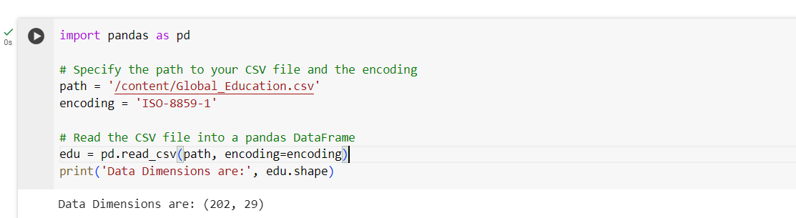
The above code reads the Global_Education.csv file using Pandas library and prints the shape of the dataframe.
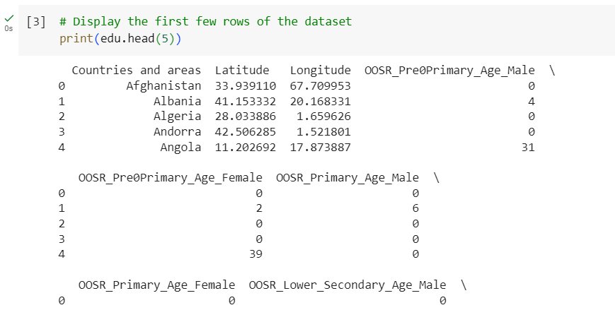
This code prints the first 5 rows of the dataset.
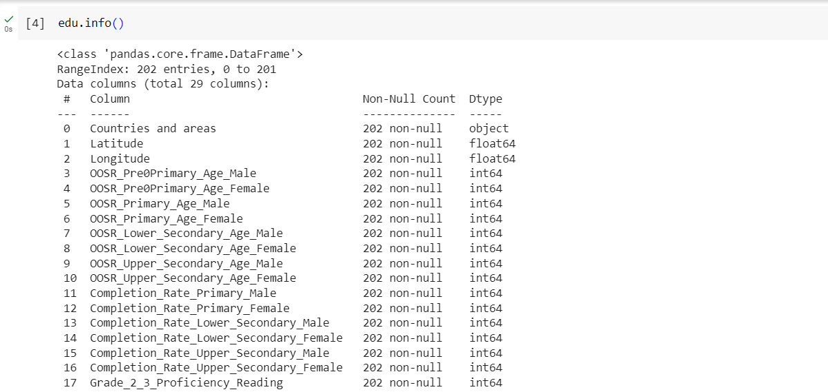
This code represents all the information existing in the dataset taken.

Exploratory Data Analysis:
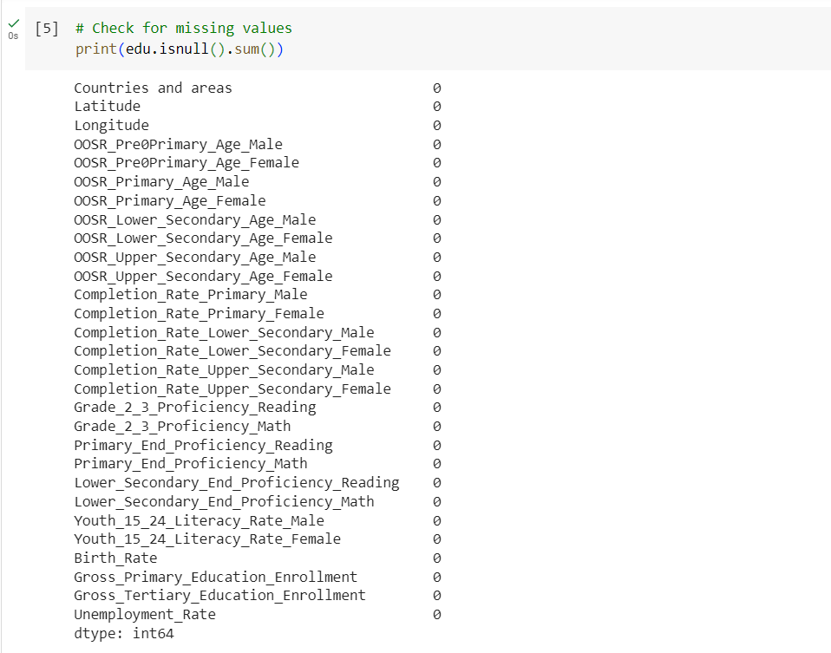
The above code results in finding the missing values for the purpose of exploratory data analysis.
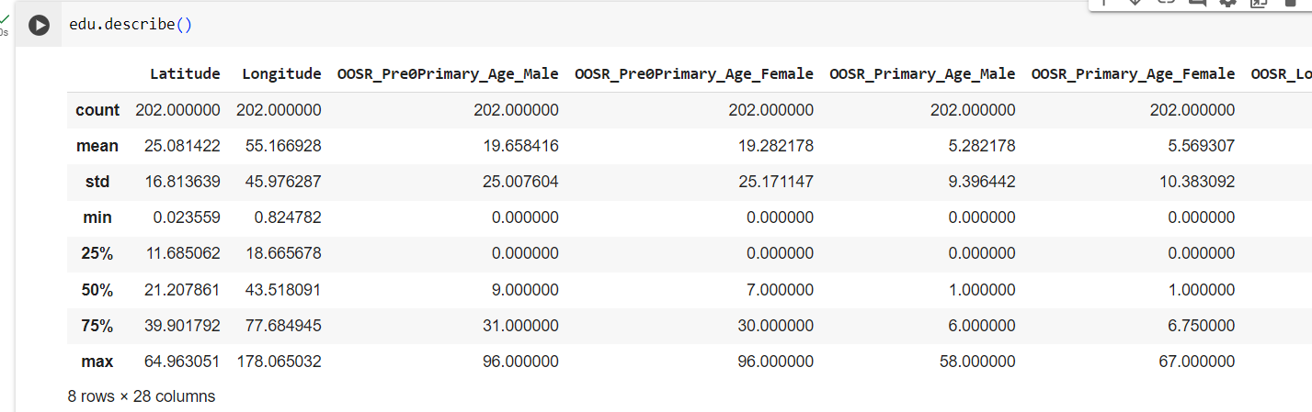
This code results in displaying the statistical analysis of the data components providing mean, count, min, max values etc for each attribute.

Data Visualization:
Let us consider some countries and regions from the dataset and perform analysis on evaluating the status of education identifying significant factors.
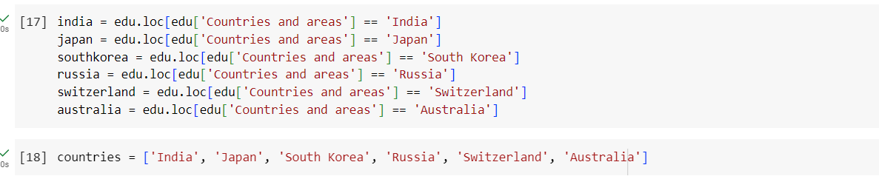
1.Visualize Out-of-school rate for pre-primary age males and females for the above countries mentioned.
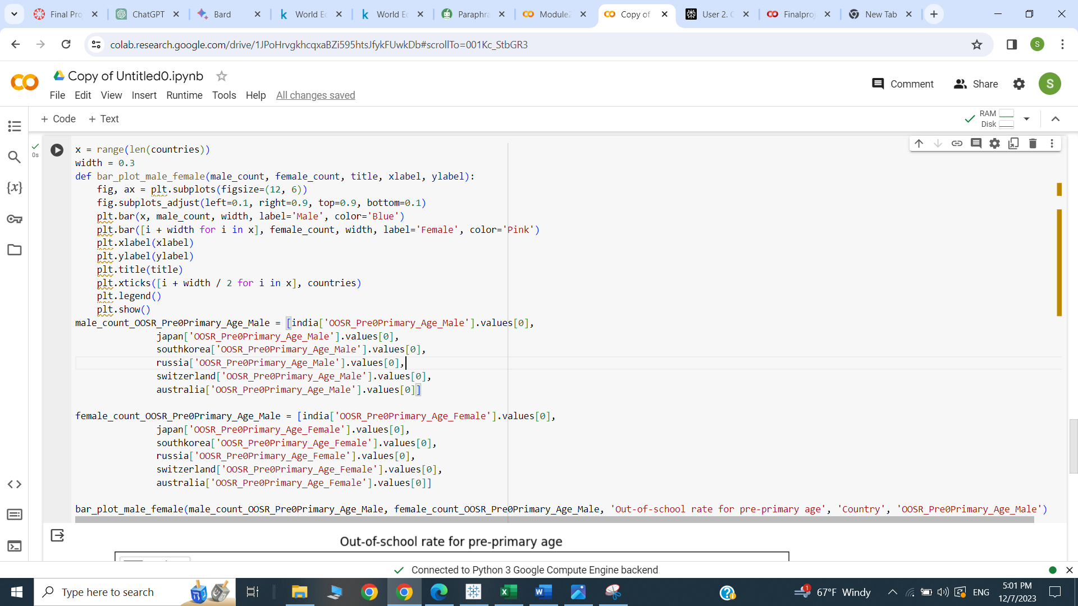

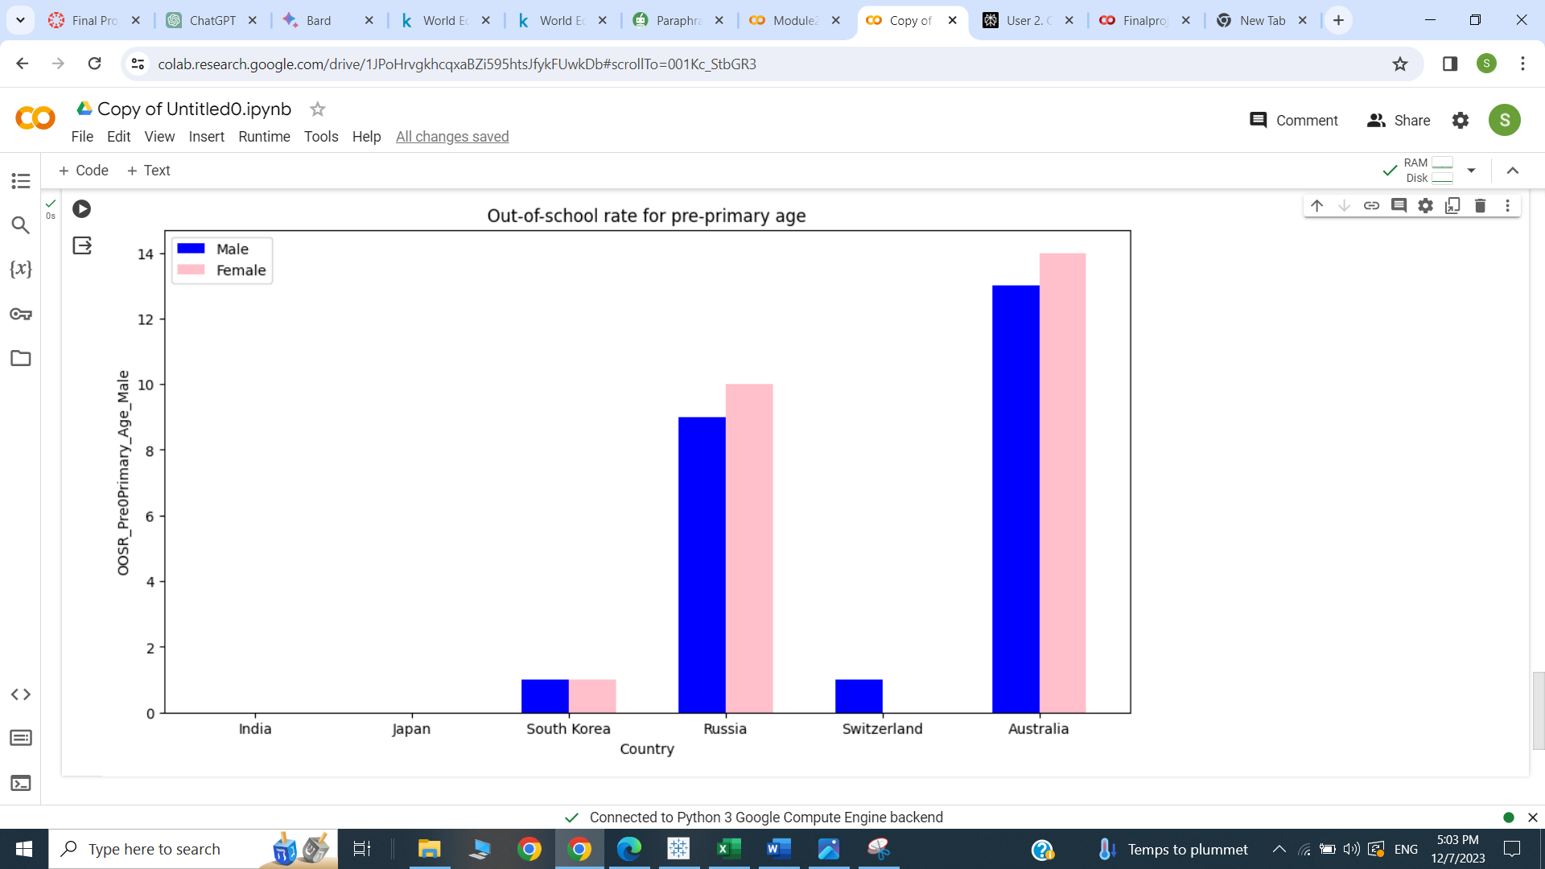
Result:
Above visualization bar plot represents the Out-of-school rate for pre-primary age of male and female in different countries. It is observed that most of females and male from Australia have greater out-of-school rate in their pre-primary age.
2.Perform data analysis on these countries and find out the proficiency among grade 2_3 students.
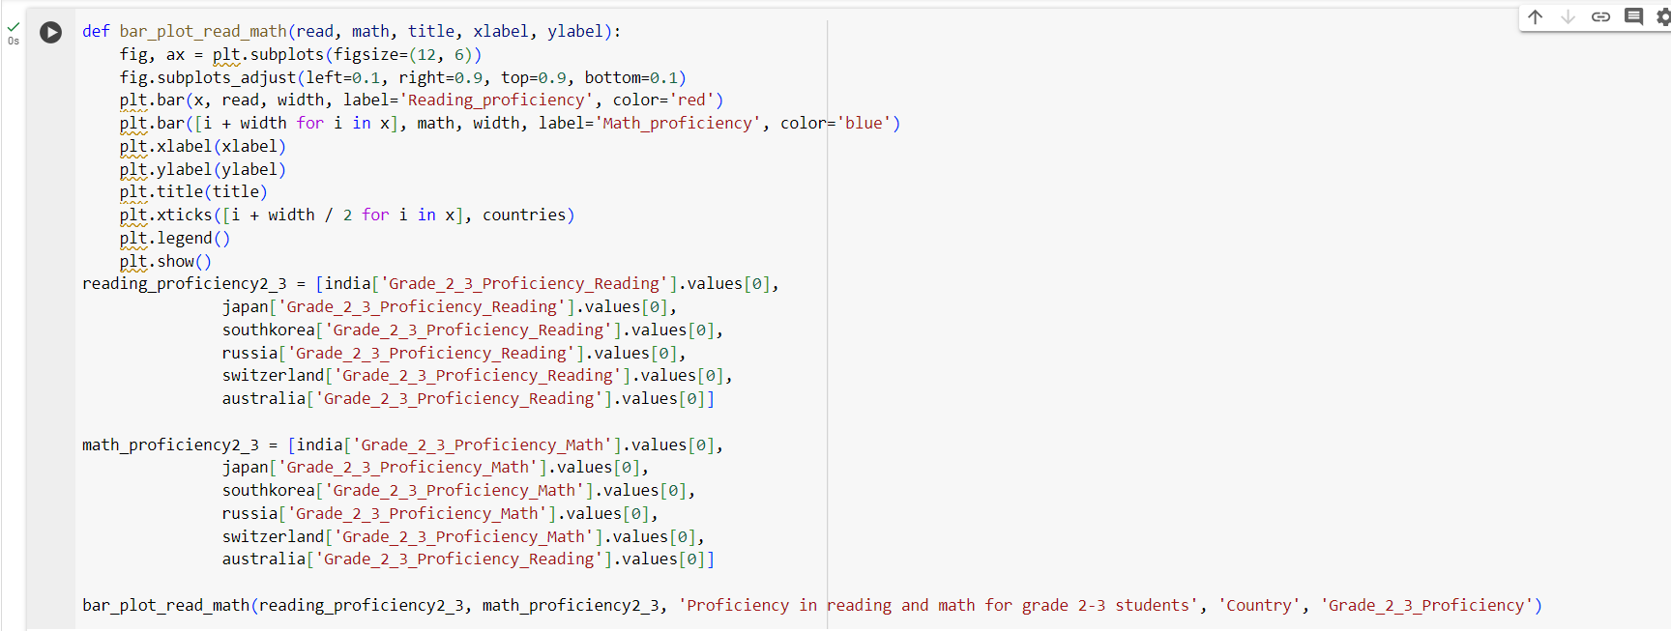
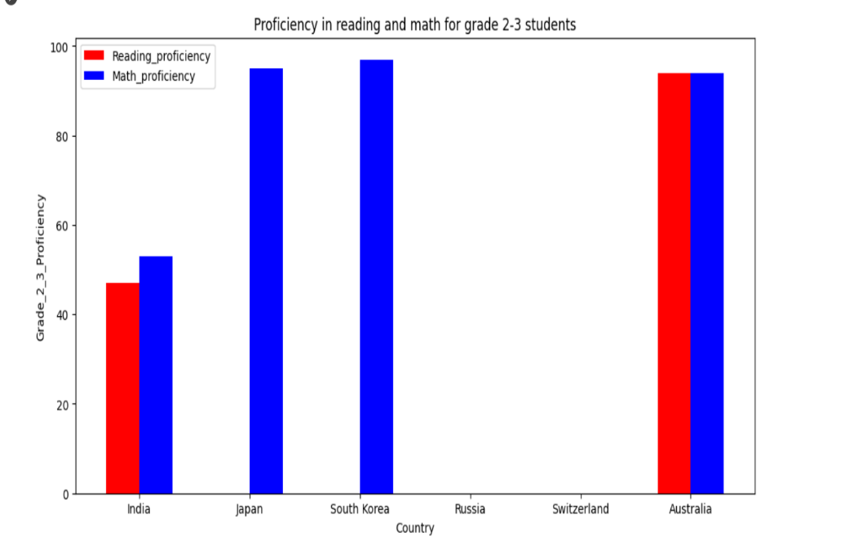
Result:
This visualization displays the reading proficiency and proficiency in math of Grade 2_3 students among the given countries. It is observed that South Korea has highest proficiency in math comparing the other countries.
3.Represent the birth rates across the following countries.
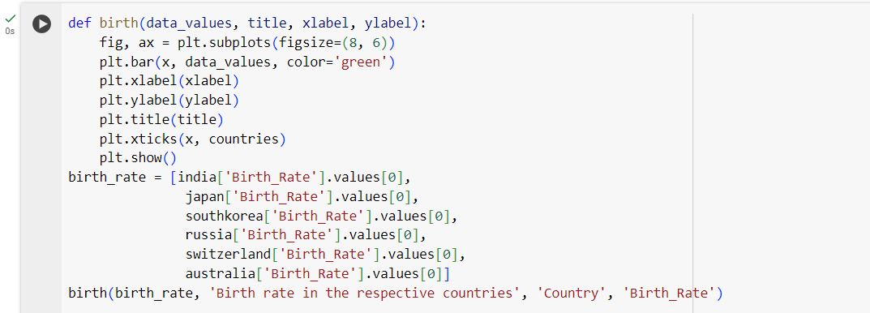
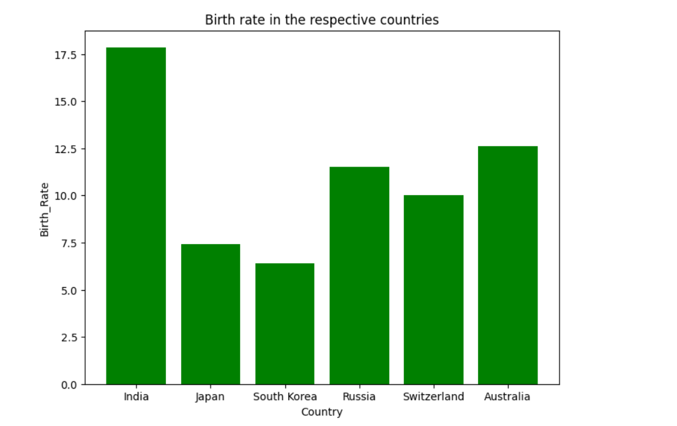
Result: The above visualization delivers the birth rate of various countries. Especially, we can observe India’s birth rate is high among other regions. It is observed that South Korea birth rate is very low.

4.Display the unemployment rate in the given countries.
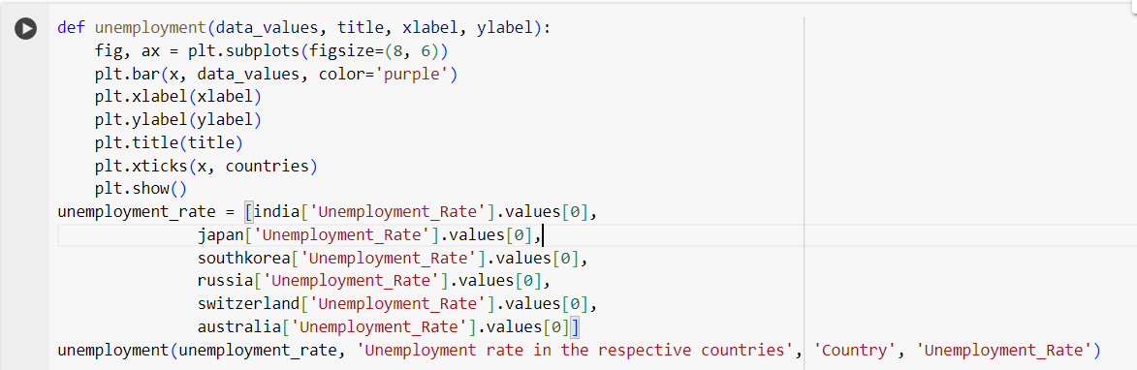
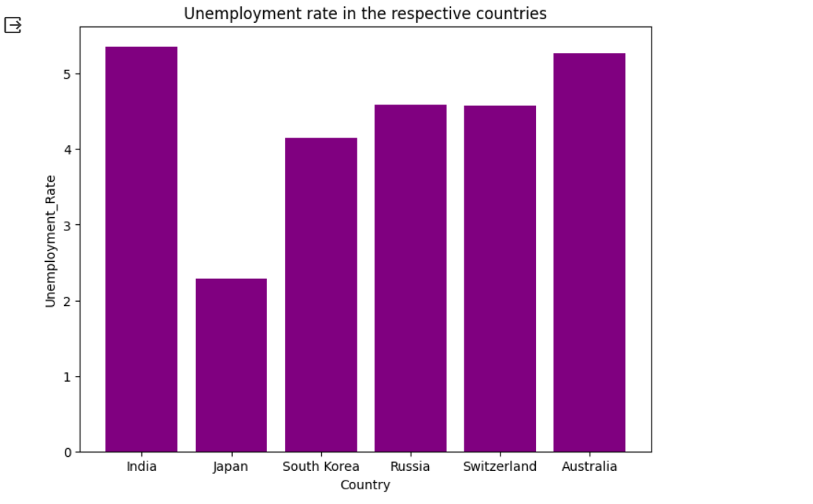
Result:
This visualization gives the unemployment rate across various countries. It is observed that the unemployment rate in India is highest than the other regions. The birth rate in India is observed to be high and this can lead to increased unemployed people. Birth rate might affect the employment status of individuals which can be directly proportional to unemployment rate.

5. Visualize the primary and tertiary education enrollments from the below countries students.
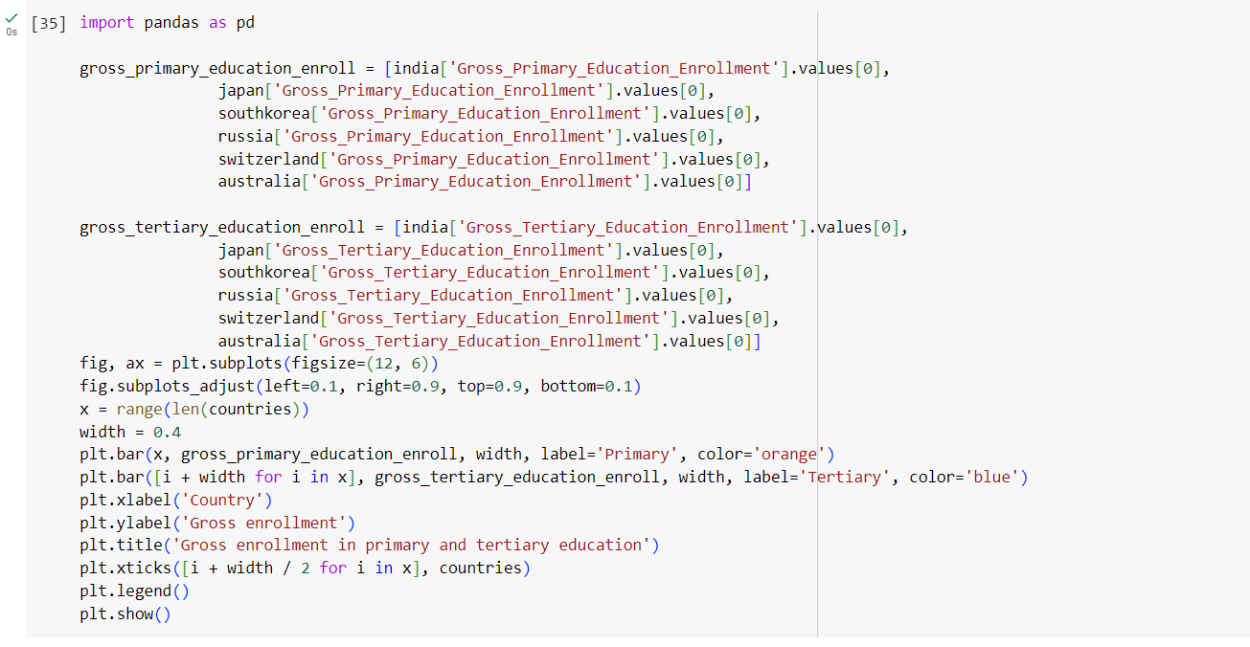
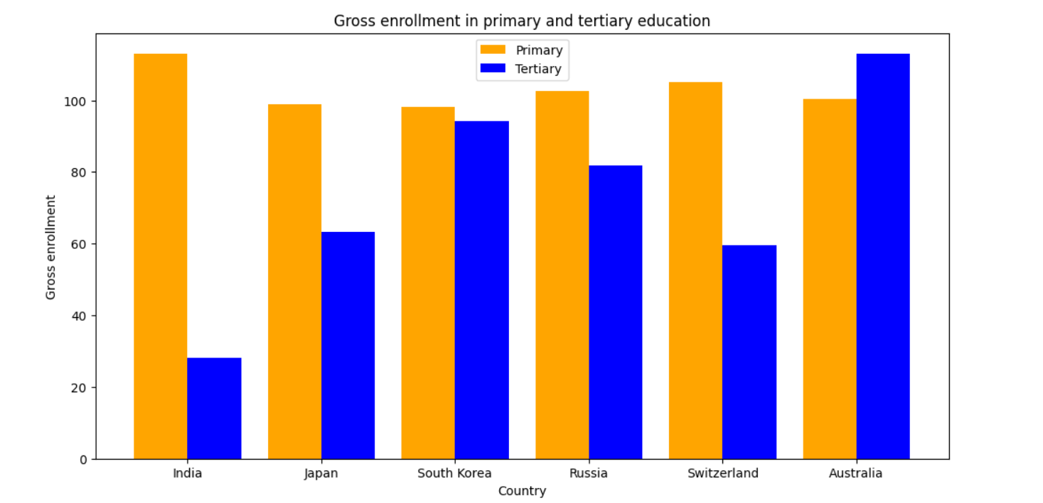
Result:
The above visualization depicts the gross enrollment in both primary and tertiary education from the countries India, Japan, South Korea, Russia, Switzerland, Australia. It is observed that in Australia tertiary gross enrollments are higher comparing to other countries.
Hypothesis:
- Is there any relationship between birth rate and gross primary and tertiary education enrollments?
- What is the average proficiency of grade 2-3 students in math and reading in each region?
- Identify the out of school rates for upper secondary age male and female and analyze the highest and lowest among the countries.
- Using interactive filters, find out and highlight all the measure values for the following countries chosen.
- Find out the literacy rate in male and female for the countries chosen with adding interactive filter, Create a dashboard to display India literacy rate in youth from ages 15-24.
To prove the above hypothesis, these data visualizations are created using Tableau.
1.Scatter plot:
- Open Tableau and connect Global_Education.csv dataset to the server.
- Drag and drop “Birth_Rate” field to the columns shelf and add Gross_Primary_Education_Enrollment”, “Gross_Tertiary_Education_
Enrollment” fields to the rows shelf.
- Drag and drop “Countries and areas” to Labels, Colors and Detail shelf to see the data points of each country.
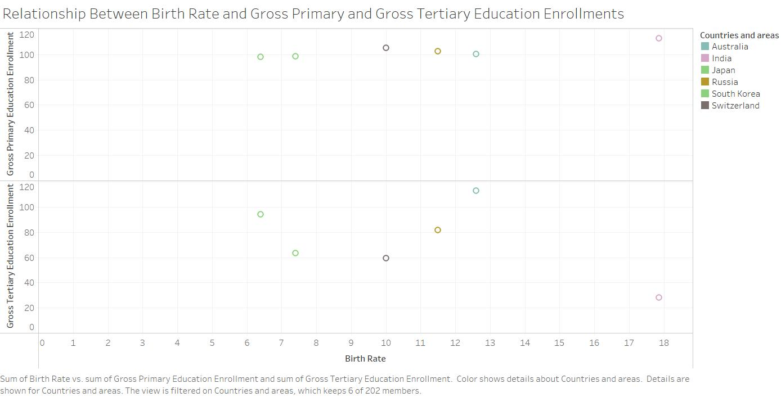
Result:
The above scatter plot visualization depicts information about birth rate in different countries corresponding to their respective gross primary and gross tertiary education enrollments. With this visualization, the relationship between the attributes is possible. Hence the given above hypothesis is proved right.
2. Line Chart:
- Open Tableau and connect Global_Education.csv dataset to the server.
- Drag and drop “Countries and areas” field to the columns shelf.
- Create a calculated field to calculate the average between grade 2_3 proficiency in math as well as reading.
- Name the calculated field as Avg_Proficiency with formula,
([Grade_2_3_Proficiency_Reading]+ [Grade_2_3_Proficiency_Math] ) / 2 and click ok.
- Drag and drop “Avg_Proficiency” to rows shelf and add “Grade_2_3_Proficiency_Reading” and “Grade_2_3_Proficiency_Math” Detail shelf to see the data points of each country.
- Change to line in marks shelf to get a line chart.
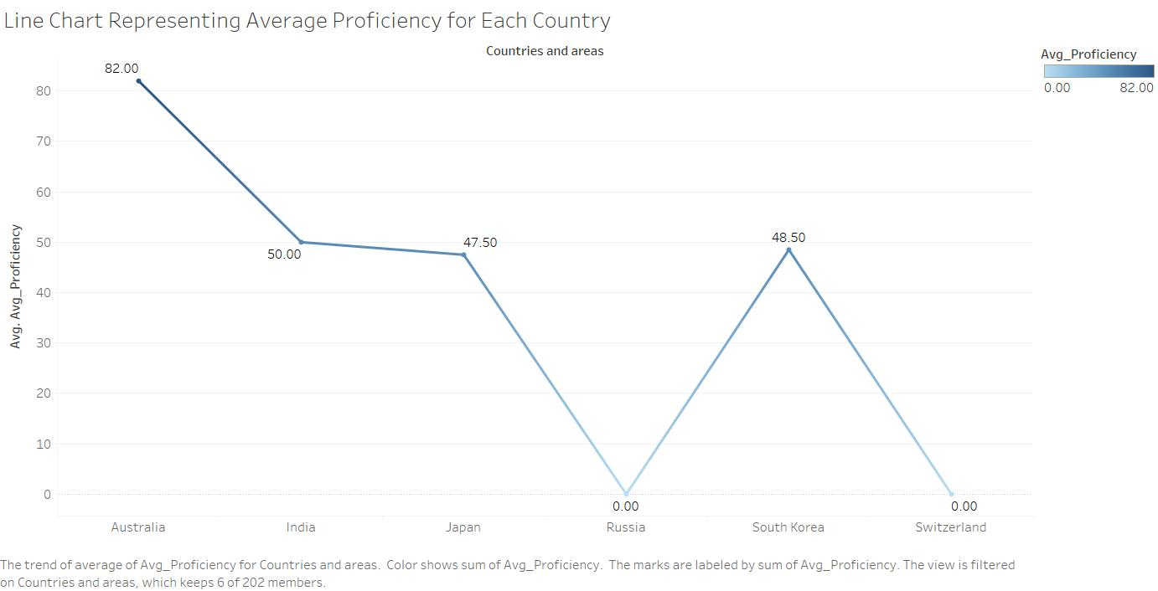
Result:
In order to prove the second hypothesis, we created a line chart with the following attributes including Avg_Proficiency with Countries and regions. This average proficiency attribute gives the average between grade 2_3 proficiency in math and grade 2_3 proficiency in reading. With this data visualization, the resulted line chart helps us to find the average of proficiency of all the countries selected and it is observed that Australia has the highest average proficiency both in math and reading hence, second hypothesis also proves right with the above visualization.
3. Bar Chart:
- Open Tableau and connect Global_Education.csv dataset to the server.
- Drag and drop “Countries and areas” field to the columns shelf.
- Drag and drop “OOSR Upper Secondary Age Male” field to the rows shelf.
- Drag and drop “OOSR Upper Secondary Age Female” field to the Color shelf and edit Colors to Purple.
- An automatic bar chart is created.
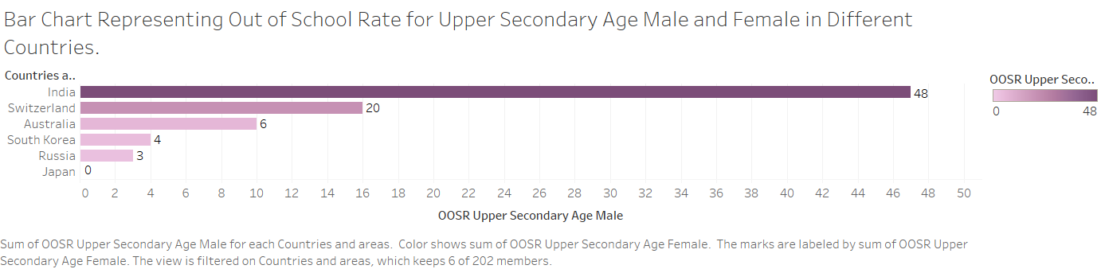
Result:
The above bar chart represents the out of school rate for upper secondary male and female in different countries. It is observed that India country has the highest count of out of school rate observed in female and male of upper secondary age among the other countries.
4.Symbol Maps And Side-by-Side Bar Graph:
- Open Tableau and connect Global_Education.csv dataset to the server.
- Create a Source Sheet named Symbol Maps
- Drag and drop “Longitude” field to the columns shelf.
- Drag and drop “Latitude” field to the rows shelf.
- Drag and drop “Countries and areas” field to the Color shelf and edit Colors to Automatic.
- Select symbol maps to create the required visualization.
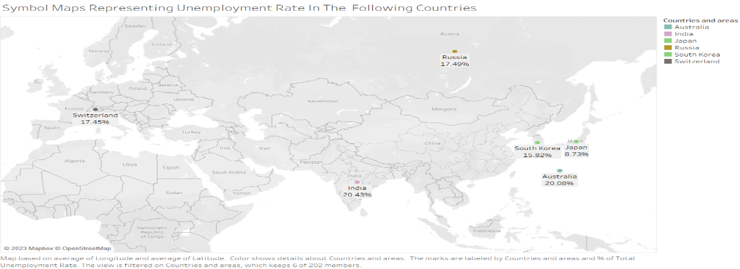
- Now, we need to create Target Sheet to apply interactive filter.
- In the second sheet, Name the target sheet as Measure values.
- Drag and drop “Countries and areas” and “Measure Names”, to the columns shelf.
- Drag and drop “Measures Values” to the rows shelf.
- Drag and drop “Measure Values” to the Label and “Measure Names” to the colors.
- The side-by-side bars are created from the show me section.
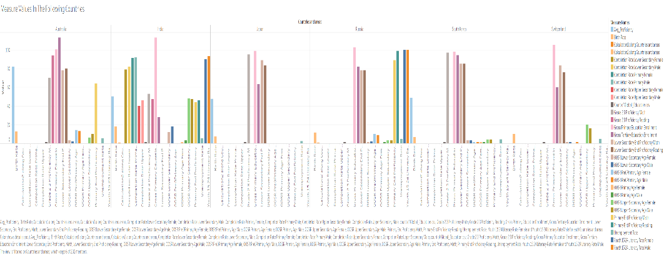
- Add the interactive filters, go to Worksheet menu, and select Actions. Next, Add Action select Highlight and select source sheet as Symbol Maps and target sheet as Measure Values. And click on Select option and click Ok.
- If we click on any country in source sheet, the data of that specific country will be highlighted in target sheet.
Source sheet:
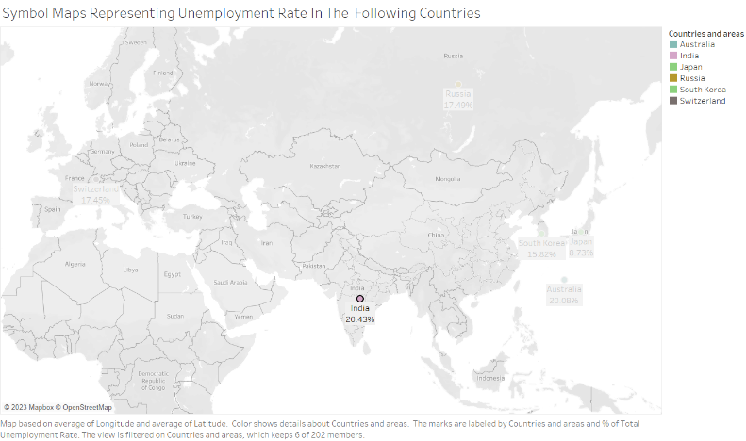
Target Sheet:
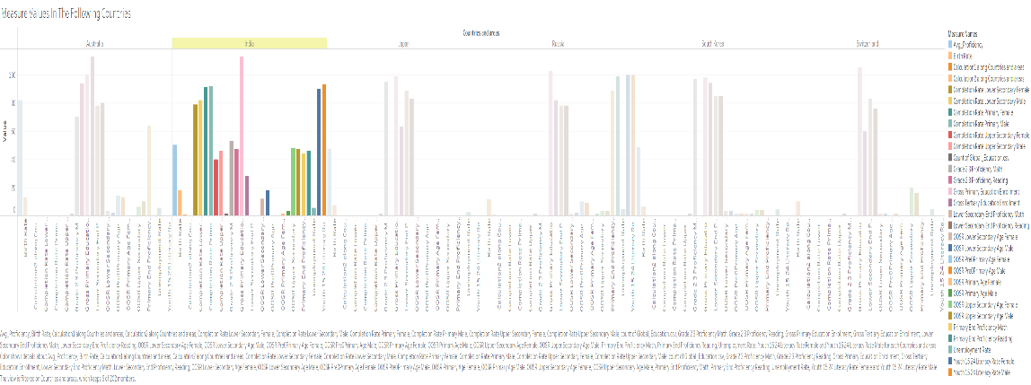
Result:
The above representation provides the visualization graphs adding with interactive features. In the source sheet, India is selected from the symbol map and then the target sheet highlights only India’s measure values from the dataset.

5.Dashboard creation to verify hypothesis:
- Apart from above sheets, I have created an additional sheet to create pie chart visualization.
- Drag and drop “Youth 15_24 Literacy Rate for female” and “Youth 15_24 Literacy Rate for Male” in the required Label shelf, drop “Birth Rate” in Size shelf.
- Pie chart is created.
- Create a new dashboard. Drag and drop Scatter Plots sheet consisting data about birth rate, gross primary education and gross tertiary education enrollments at the first section of the page.
- Add a title box on the top of dashboard and name it with the project title as World Education Data.
- Drag and drop the other sheets side-by-side bar, bar chart, line chart and pie chart which are already created.
- Go to Dashboard menu, click on actions. Add a new action. Select Filter and name the filter.
- Select the source sheet and target sheet as dashboard and click on Hover and click ok.
- When the cursor hovers on India country the dashboard displays the information about its gross primary, gross tertiary education enrollments in scatter plot.
- It also displays the average proficiency calculated with line chart, the literacy rate of youth in ages between 15 and 24 both female and males are represented.
- The out of school rates of upper secondary female and male ratio along with all the measuring values of attributes in the dataset are displayed.
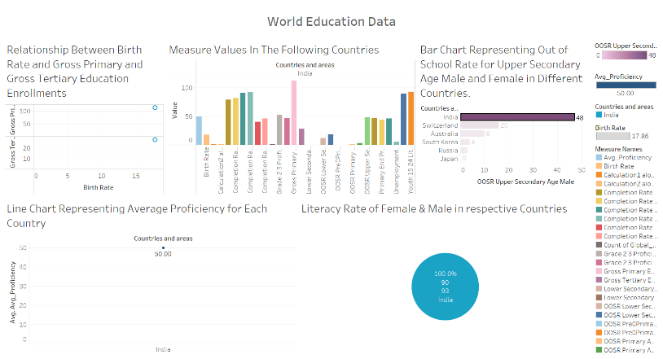
Result:
This dashboard proves all the hypothesis required to provide the detail information of the selected countries.

Conclusion:
This project helps us to analyze the dataset about education in different countries of the world. It includes about the birthrate, gross primary and tertiary education enrollments, out of school rates of male and female, unemployment rate, literacy rate of youths. Furthermore, it provides a clear understanding about educational aspects of data which are collected globally across the world.

References:
- "The Global Teacher Project". Globalteacher.org.uk. Retrieved 2015-05-20.
- ^ "What is global education? | GLEN". Glen-europe.org. Archived from the original on 2012-07-30. Retrieved 2015-05-20.
- ^ Global Education in the U.S. (n.d.). Retrieved April 24, 2016, from http://www.nea.org/home/37297.htm
- Standish, Alex (2014). "What is global education and where is it taking us?". The Curriculum Journal. 25 (2): 166–186. doi:10.1080/09585176.2013.870081. S2CID 143384285.
- Global Education in the U.S. (n.d.). Retrieved April 24, 2016, from http://www.nea.org/home/37297.htm

